## Deploying and Running Docker Containers –Whole Practice Assignment

**1. Problem:**

Build multiple Docker environments for development, testing, and production purpose. Build the Docker image from your application source code and publish your Docker images to Docker Hub.

Create a production environment with remote access and pull the Docker image to your production environment.

**Solution:**

Created application and pushed to github with docker file.

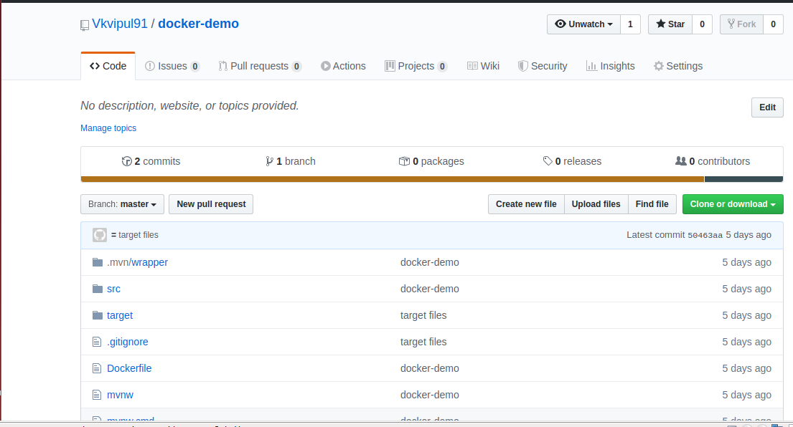

**Docker File:**

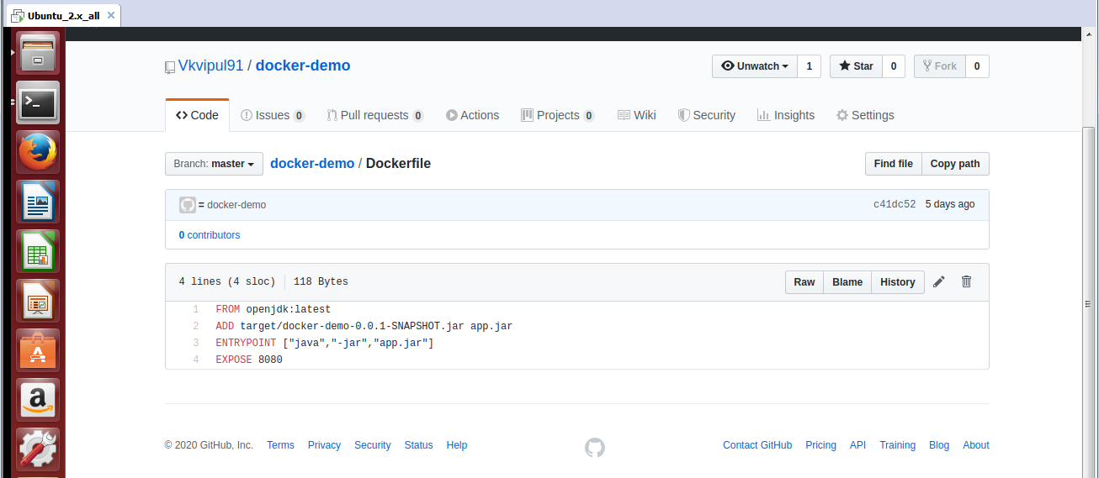

**Docker Pull:**

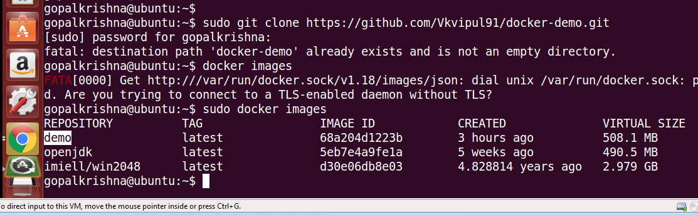

**Docker Images:**

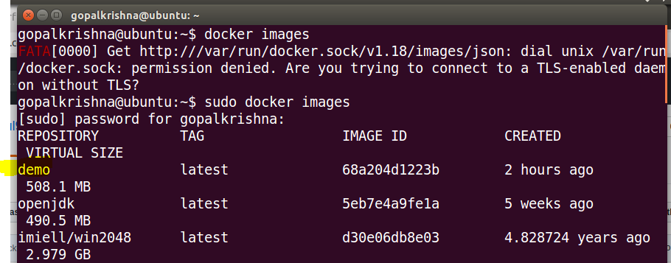

**Docker Run (Application):**

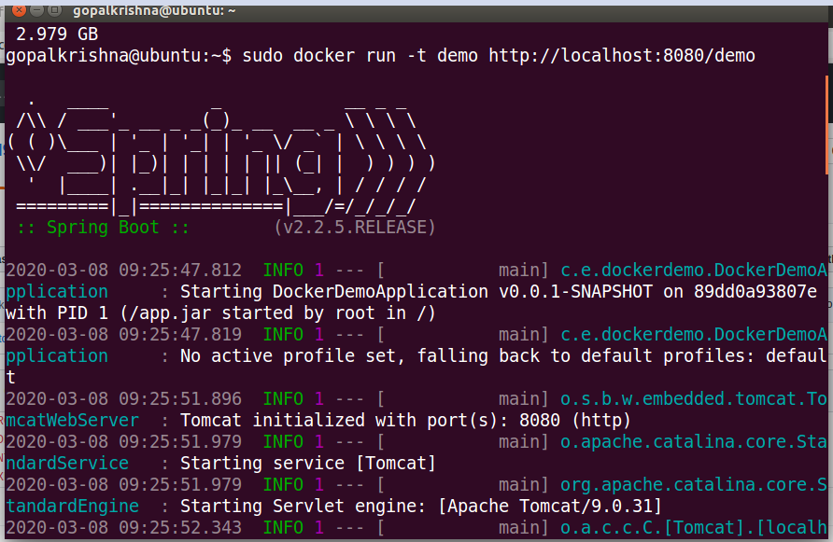

**Docker Log from the container:**

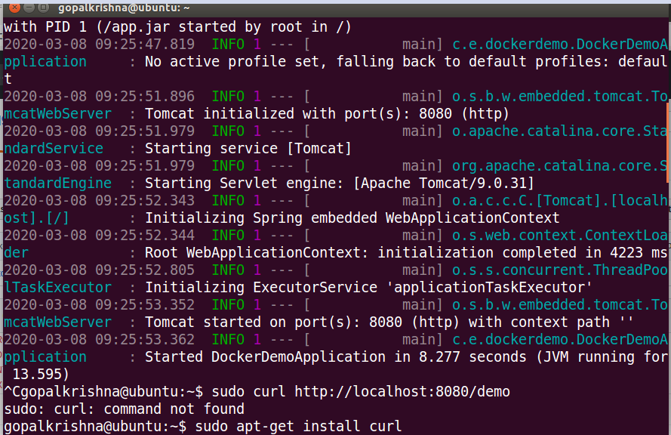

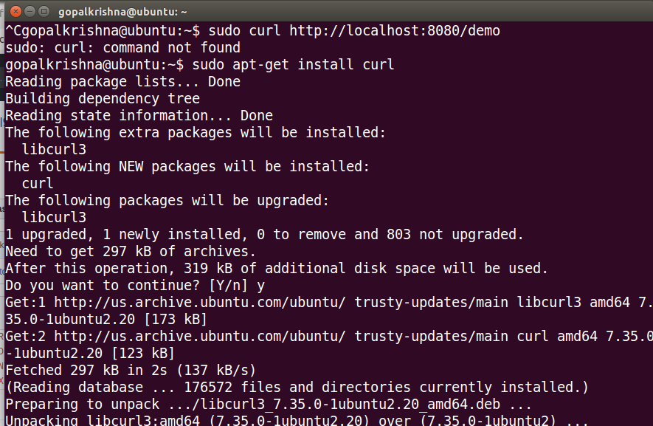

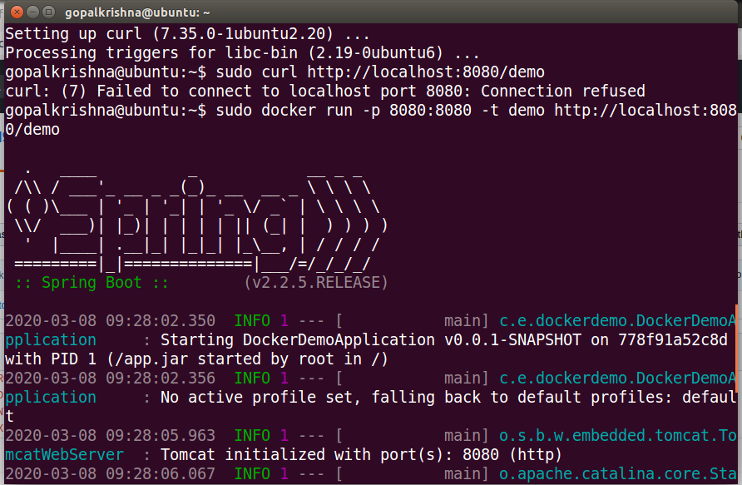

**Browser output:**

